Meaning and Objectives of Planning
Planning is a process of setting objectives and deciding how to accomplish them. Planning in sports is required because there is a definite time frame for achieving the objectives and the resiilts are also known very clearly and in definite terms.
Objectives of planning are given below.
- Timely achievements of targets.
- Improving the percentage of success.
- Finding out the causes of failure.
- Deciding the appropriate time duration of a programme.
- Distribution of work according to the ability of the people involved.
- Remaining within the budget while achieving the required targets.
Various Committees and their Responsibilities
- Committee for Publicity Its main duty is to advertise the sports events.
- Transport Committee Its main responsibility is to make necessary arrangements for transportation.
- Grounds and Equipment Committee This committee is responsible for making the grounds or laying out the track and field. , .
- Refreshments and Entertainment Committee This committee takes the charge of supplying refreshments and drinks to the guests, officials, competitors etc.
- Reception Committee The members of this committee are responsible to welcome the chief guests at the opening and closing ceremonies. .
- Committee on Entries and Programmes This committee sends entry forms to the various institutions early. It also arranges seats for guests and spectators. It sometimes also prepares fixtures of teams participating in the competition.
- Committee for Officials This committee selects various officials such as referees, judges, umpires etc.
- Announcement Committee This committee is responsible for making all the announcements during the period of sports events,
- First Aid Committee This committee provides first aid to the victim or affected sportsman/athlete.
For successful organisation of the sports meet, committees are formed under three heads These are Pre-meet committees like publicity, ground and equipment, reception committee During meet committees like refreshment, transport committee and Post-meet committees like award committee.
Tournaments
A tournament is a competition held among various teams in a particular activity according to a fixed schedule where a winner is decided.
There are various methods for organising a tournament which depends upon various factors such as
- The number of participating teams Facilities of ground, equipment and number of officials available
- Days in which the tournament is to be completed
Importance of Tournaments
- Development of Sports Skills Various skills of sports are developed in tournaments.
- Helpful in Selection of Players Good players can be selected easily by observing their performance in the tournament.
- Development of National and International Integration It not only develops the integration of national and international level but also gives sense of unity and brotherhood.
- Development of Social Qualities Social traits such as respect, brotherhood, discipline, sympathy, tolerance etc are developed among participants through tournaments.
Types of Tournament
- Knock-out or Elimination tournament
- League or Round Robin tournament
- Combination tournament
- Challenge tournament
1. Knock-out or Elimination Tournaments
A single elimination tournament (also called an Olympic system tournament) or a knock-out tournament is a type of elimination tournament where the loser of each bracket is immediately eliminated from the tournament. In such tournaments, if the number of competitors or competing teams are not a multiple of 2 (i.e. 4, 8, 16,..) then some teams may be given a ‘bye’ and some teams are given ‘seeding’.
Seeding is a procedure by which good teams are placed in fixtures in such a way that stronger teams do not meet each other at the very start of a tournament.
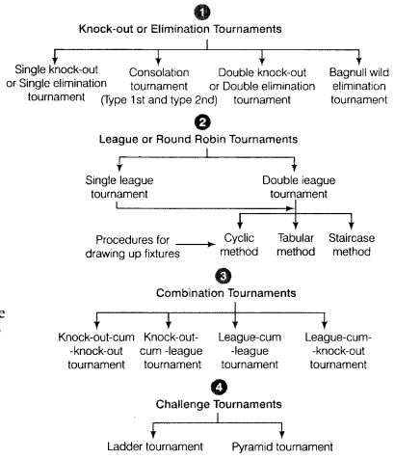
Note We will cover in detail the first three tournaments because these three tournaments are included in syllabus.
Bye is a privilege given to a team which is decided generally by seeding it or by draw of lots.
Advantages of Knock-out Tournaments
- Minimum number of officials are required in organising tournaments.
- Owing to less number of matches so it takes less time to complete the tournaments.
- It helps in enhancing the standard of sports.
Disadvantages of Knock-out Tournaments
- Good teams can get eliminated because of their poor performance even in first round.
- There are maximum chances of weak teams to enter into the final round.
2. League or Round Robin Tournaments
A league tournament, also called as round robin tournament, is a type of tournament in which each contestant meets all other contestants in turn. In this type of tournament, there has to be sufficient time to complete the tournament.
There are two types of league tournaments
- Single league
- Double league
In a single league round robin schedule, each participant plays with every other participant once. If each participant plays with others twicely, this is frequently called a round robin double league tournament.
- Single League Number of matches =N(N−1)2 (N = Number of teams)
- Double League Number of matches = N (N-1) (N = Number of teams)
Fixture
Any tournament whether it is knock-out or league, is arranged according to a set procedure which is known as fixture. For knock-out tournament, the procedure to draw fixture is through bye and seeding. For league tournaments, the procedure to draw fixture is through staircase and cyclic method.
Fixture is the process of arranging the teams in systematic order in various groups for competition in a physical activity. In other words, it is the set-up of various teams for competitive matches where they play in a systematic order as per the fixture schedule. The success of a tournament depends upon planning of suitable fixture. Tournaments are played in various forms of fixtures.
Fixtures in Knock-out Tournament
In a knock-out tournament, the fixtures are drawn by the following methods
1. Seeding Method
Seeding is a procedure by which good teams are placed in fixtures in such a way that stronger teams do not meet each other at the very start of a tournament. It is done to overcoine the drawbacks of a single knock-out tournament. Seeding can be done only if the standards of the teams are known before the start of the tournament. The draw may result between the strong competitors at early level competition, so they are ‘seeded’ to prefvent this.
Thus, the top competitors will not meet until the quarter final, semi final or final round. Seeding is used to ensure that-players or teams of recognised outstanding abilltytlo not confront each other in the early rounds. It represents the tournament committee’s subjective rating of the various players, and chances of winning the tournament.
Special Seeding
It is a method of seeding in which the players or teams directly participate in the quarter final or semi-final matches thus avoiding their participation in the initial rounds.
2. Bye Method
Bye means the avoiding of playing a match in the first round of the tournament. It is a privilege given to a team which is decided generally by seeding it or by draw of lots. Some teams may get bye in first round, by which they get promoted to higher round competition.
This may be given as a reward for their some previous achievements. Byes can be applied equally to single person competitions and team sports as well as to single game eliminations and best of series elimination. Byes are given in 1st round only. The number of byes that should be given in a tournament is decided by finding the difference between the number of teams and the next power of two.
Example : (N – 1) if 20 teams are participating, then 19 matches (20 – 1) =19 will be played.
Method of Drawing Fixtures in Knock-out Tournament
In order to draw fixtures in a knock-out tournament, following things are essential to calculate
1. Total Number of Matches It means the total number of matches that will be played during the entire tournament. The number of matches to be played is calculated by subtracting 1 from total number of teams (N – 1).
Suppose total teams are 11 so matches to be played during the tournament are 10 (11 – 1).
2. Number of Rounds It means the total number of rounds that should be played during the tournament. Rounds will include the initial rounds, quarter finals, semi finals and finals. If the number of teams is a power of 2, then number of rounds will exactly be multiple of 2 up to that number.
Example :
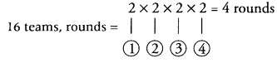
If number of teams is not a power of 2, then number of rounds will be equal to the multiple of next power of two.
Example :
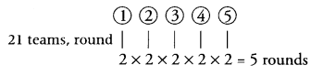
The next power of 2 after 21 is 32 which is 25.
3. Number of teams in each half All the teams are divided into two halves for the sake of convenience. If the number of teams is even, then the number of teams in upper and lower half will be equal i.e Total teams 20 then apply the formulae N2
Number of teams in upper half
N2=202=10
Number of teams in lower half
N2=202=10
If the number of tearms is odd ,then applyN+12 for upper half and N−12
Example : Total teams = 15
Number of teams in upper half
N+12=15+12=8
Number of teams in lower half
N−12=15−12=8
4. Number of byes Teams getting the byes do not play in the initial round. They are given by subtracting the number of teams by the next power of 2.
Example 1 : Total number of teams =19
Next power of two after 19 = 32
Power of two – 2¹ = 2, 2² = 4, 2³ = 8, 2⁴ = 16, 2⁵ = 32
therefore number of byes will be 32 – 19 =13
Example 2 : Total number of teams =12
Next power of two after 12 = 16
therefore number of byes 16 – 12 = 4
Hence, 13 teams in example 1 and 4 teams in example 2 will not play the match in 1st round.
5. Number of byes in upper and lower half
For calculating how many teams in upper and lower half will get byes, the method is as follows
Number of byes in upper half = Nb−12
Number of byes in lower half= Nb+12
Total number of byes = 13
Number of byes in upper half= 13−12=6
Number of byes in lower half= 13+12=7
6. Method of fixing byes The number of the teams are placed in upper and lower half according to the draw of lots or using other methods. Then following procedure is adopted for fixing the byes.
The last team of lower half gets first bye.
The first team of upper half gets second bye.
The first team of lower half gets third bye.
The last team of upper half gets fourth bye.
The second last team of lower half gets fifth bye.
Like this the order continues.
7. Method of Seeding It is done to prevent the strong teams from competing with each other in the initial round. Therefore the strong teams are placed in the position where they will get bye i.e. placing the strong teams on the last position of lower half or first position of upper half.
Example : Total no. of teams = 6
Next power of two after 6 = 8
No. of byes 8 – 6 =2
Seeding = Last of lower half and first of upper half.
Number of matches 6 – 1 = 5
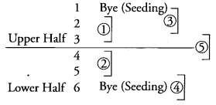
Examples
Example 1 A fixture of 19 teams on knock-out basis.
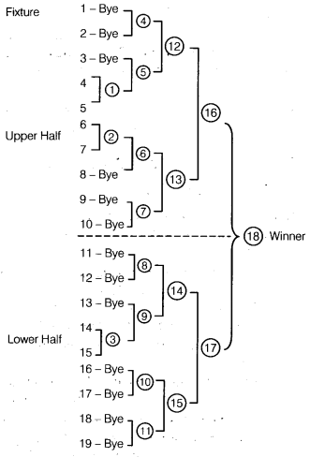
Total matches = N – 1 = 19 – 1 = 18
Number of teams in upper half
N+12=19+12=202=10 teams
Number of teams in lower half
N−12=19−12=182=9 teams
Total number of byes
= Next power of two – Total number of teams = 32 – 19=13 byes
Number of byes in upper half
Totalnumberofbyes−12
i.e[Nb−12]=13−12=122=6byes
Number of byes in lower half
=Totalnumberofbyes+12
[Nb+12]=13+12=142=7byes
Example 2 A fixture of 12 teams where 4 teams getting special seeding.
Total number of teams =12
Number of teams m upper half = N2=122=6
Number of teams in lower half = N2= 6
Teams setting special seeding = 4
Number of matches = 12 – 1 = 11
Fixture
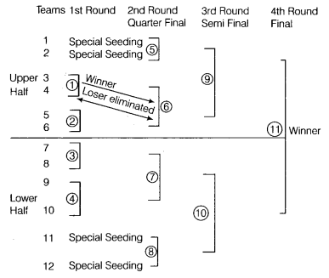
Team number 1,2, 11 and 12 do not play the match initially as they get special seeding.
- Winner of each bracket enters the next round while losers are eliminated. For example, Team 3 and 4 play match number 1. If 3 wins, then 4 is eliminated from the tournament.
- If the number of teams/ players is odd, then number of teams in upper half and lower half each is N+12
- Teams getting special seeding do not play initial rounds just like byes
Fixtures in League Tournaments
The three methods used for drawing up fixtures are
- Staircase method
- Cyclic method
- Tabular method
Note We will cover in detail the first two methods because these two methods are included in syllabus.
1. Staircase Method
In this method, the fixtures are made like a staircase. It is arranged in sequential form, there is no bye, no problem of odd or even and therefore it is easiest to arrange. An example will illustrate this method.
Example : Draw up a fixture of 9 teams on Round Robin basis using staircase method.
The number of teams = 9
Thus, number of matches
N(N−1)2=9(9−1)2=9×82=36matches
The fixture is given below
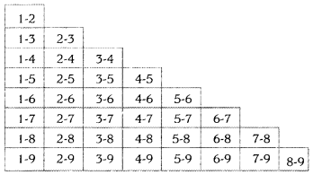
2. Cyclic Method
In this method, if the number of teams is even (i.e. 4, 6, 8, ….), team 1 is fixed on the top right side and the other teams move in clockwise direction down one side of a rectangle and up on the other side. In such a case, the number of rounds will be N-1 if there are N teams participating. However, if the number of teams is odd (i.e. 3, 5, 7,….), a ‘bye’ is fixed at the top and all teams follow it in sequence. In such a case, the number of rounds will be N.
Example 1 Fixture of 6 teams on cyclic method.
Total number of teams = 6
Total number of matches = N(N−1)2=6(6−1)2=15
Total number of rounds = N – 1 = 5
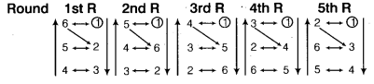
Example 2 Fixture of 5 teams on cyclic method.
Total number of teams = 5
Total number of matches = N(N−1)2=5(5−1)2=10
Total number of rounds = 5
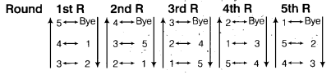
Deciding the Winner
The method to decide the winner in the tournaments is by calculating the percentage of matches won.
percentage=MatchesWonMatchesPlayed×100
1.5 Intramurals
The word intramural is derived from the Latin words intra and muros, which means ‘within walls’. The teams compete within the walls of the institution e.g. inter-class or inter-house tournament within an institution.
The objectives of intramurals are as follows
- To provide incentive, motivation and opportunity to learn various skills.
- To develop sportsman spirit among students.
- To help in recreation of the students.
- To improve-social interaction among the students.
Intramural competitions are conducted by the intramural committee of the institution.
Significance of intramurals are as follows
- It improves the sense of citizenship and adult living. ,
- It helps in selection of teams for participation in extramural tournaments.
- It brings out the hidden talent of the students.
- It develops leadership qualities in students.
- It creates recreational atmosphere among the teachers and students.
1.6 Extramurals
This encloses the activities which are performed outside the walls of the institution or school. It means that students of two or more schools participate in such competitions.
The objectives of extramurals are
- To improve the standard of sports.
- To provide experience to students.
- To develop sportsmanship and fraternity.
- To broaden the base of sports.
- To provide the knowledge of new rules and advanced techniques.
Significance of extramurals are as follows
- They provide recreational opportunities for the campus community. ..
- They give positive experiences, regardless of race, nationality, age and gender.
- They provide an opportunity to develop motor skills which will be beneficial throughout life.
- They develop important values and skills such as self-esteem, social skills, sportsmanship and self-motivation.
- They give an opportunityfor relaxation from strenuous school work and the rapid pace of modern living.
1.7 Specific Sports Programmes
Specific sports programmes are those which are not usually related to competitions. The programmes have various objectives like creating awareness, creating a sense of integration among people and raising funds for charitable organisations. Some of these programmes are Sports day. Run for fun, Health run, Run for specific cause. Run for unity and Run for awareness.
.

